Jesus, the one who was promised
Reading: Isaiah 9:6-7
God will give us a son who will be responsible for leading the people. His name will be “Wonderful Counsellor, Powerful God, Father who lives forever, Prince of Peace.” His power will continue to grow, and there will be peace without end. This will establish him as the king sitting on David’s throne and ruling his Kingdom. He will rule with goodness and justice forever and ever. The strong love of the Lord All-Powerful will make this happen!
Thought about the reading
Today’s reading was written by a prophet called Isaiah. A prophet is someone who takes messages from God to God’s people. Isaiah lived a long time before Jesus was born.

When Isaiah wrote this, the people of Israel were facing a difficult time. Other nations around them were threatening to go to war with them. Isaiah gave them this message to tell them that no matter how hard things were, there was hope. One day God would send a baby who would grow up to be the king. He would rule over them, and he would bring peace.
Today we know that the baby who was promised was Jesus. He is the promised king who rules over the Kingdom of God. One day he will bring peace to the whole world.

I expect you are busy getting ready for Christmas, buying presents and cards and going to Christmas parties. In the church, this time of year is called ‘Advent’ and it is the time of year when Christians get ready to welcome the birth of baby Jesus, the baby who was promised hundreds of years earlier.

Prayer

Father God, thank you that you promised your people that a baby would be born who would grow up to the Prince of Peace. Thank you that you kept you promise when Jesus was born.
As we get ready for Christmas, please help us to remember the baby who was born for us, our Saviour Jesus.
Amen

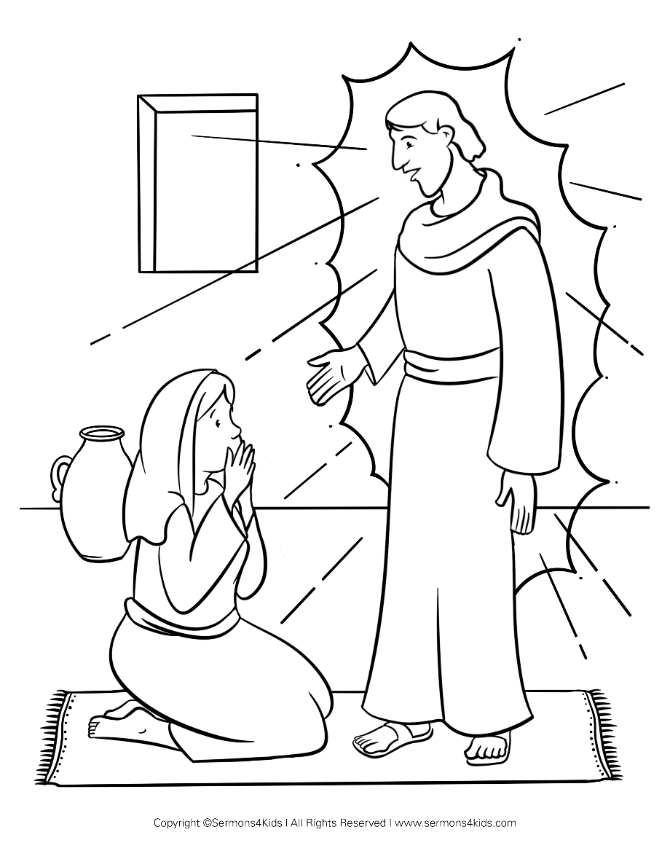
The angel Gabriel told Mary that she was going to have a baby. The baby was to be called Jesus. He was the one promised by God

Cambridge Causeway

Autumn 2025
Bible Study notes

Jesus the Reason
6. Jesus, the one who was promised
By Chrissy Cole

